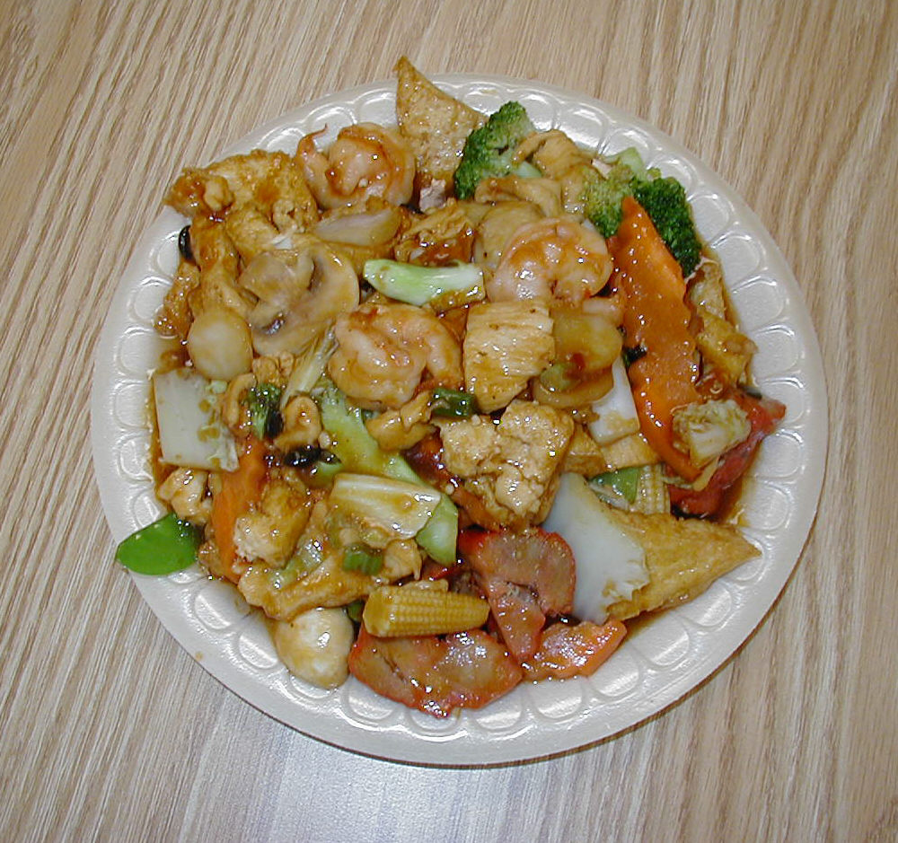
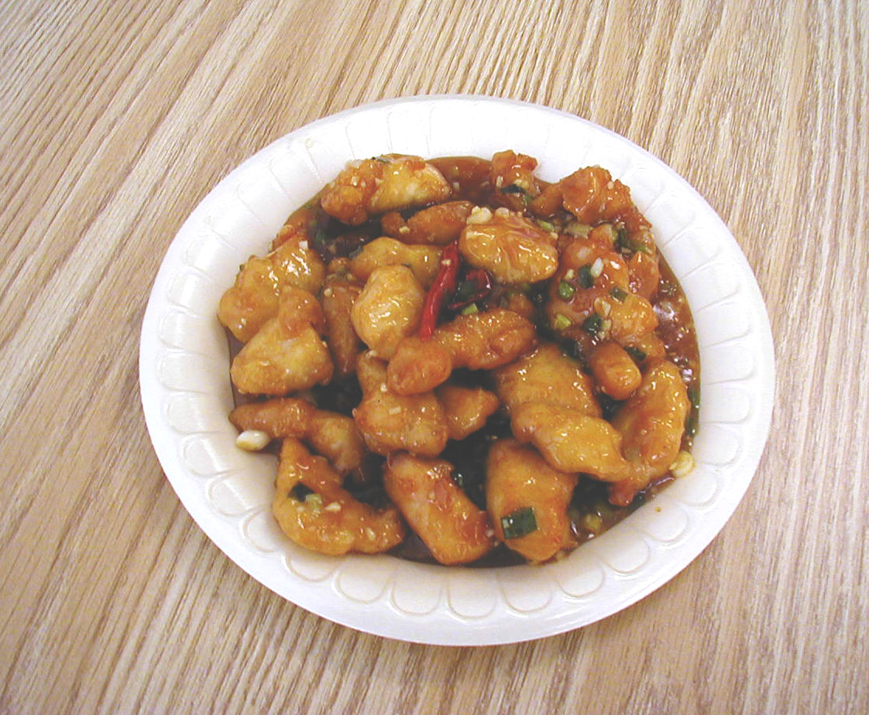
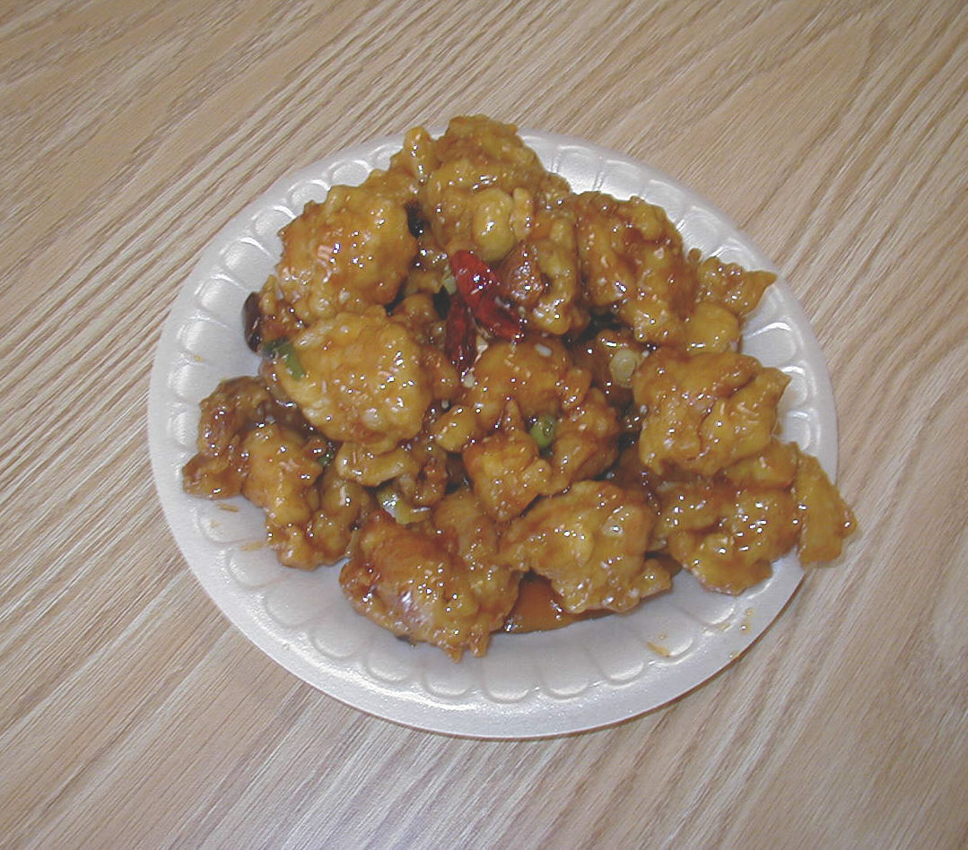
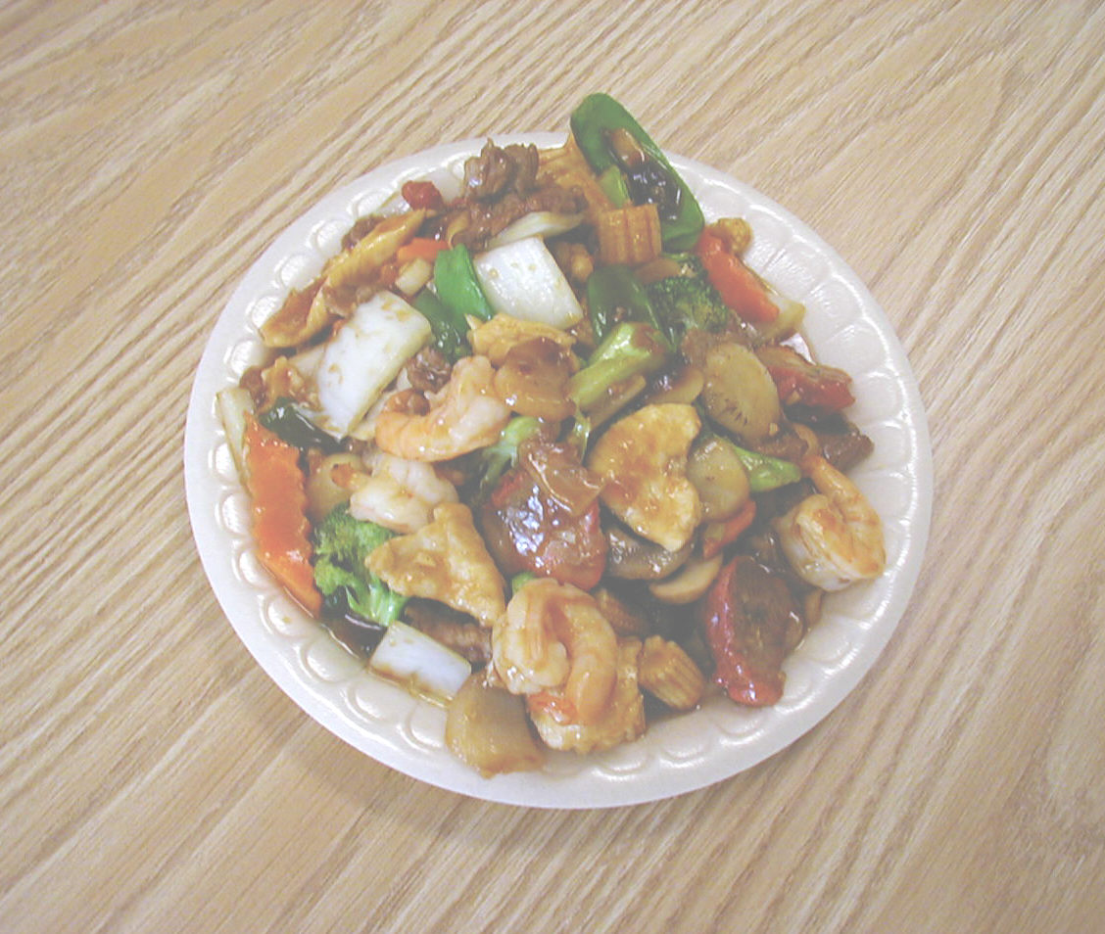
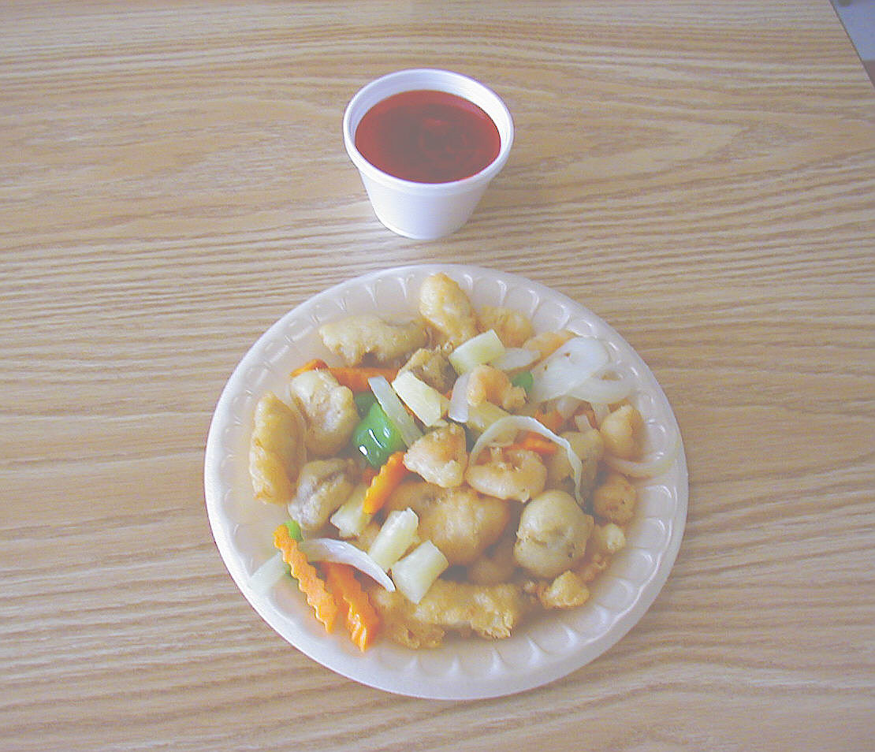
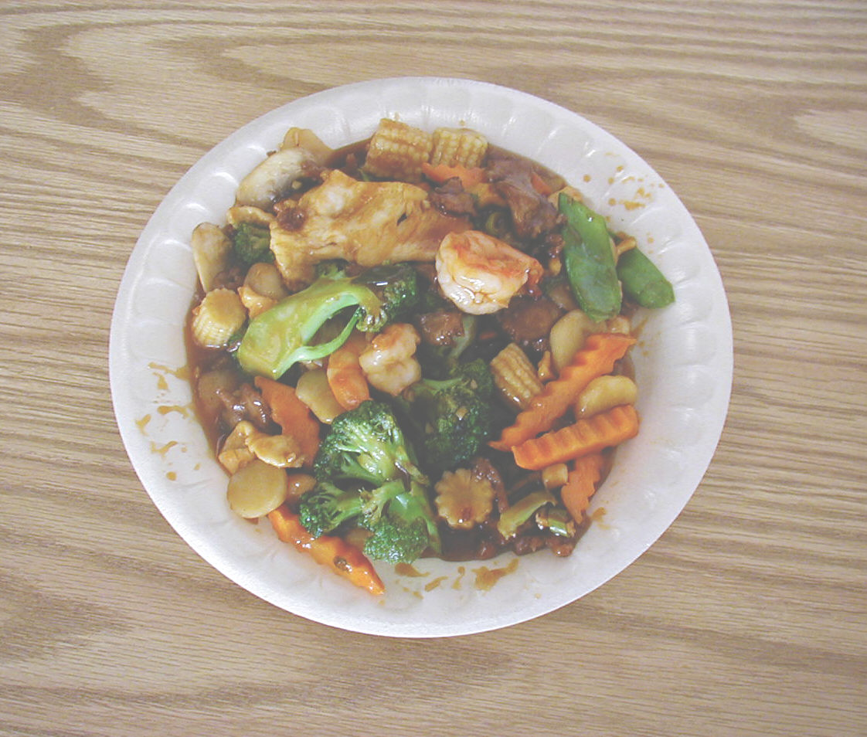
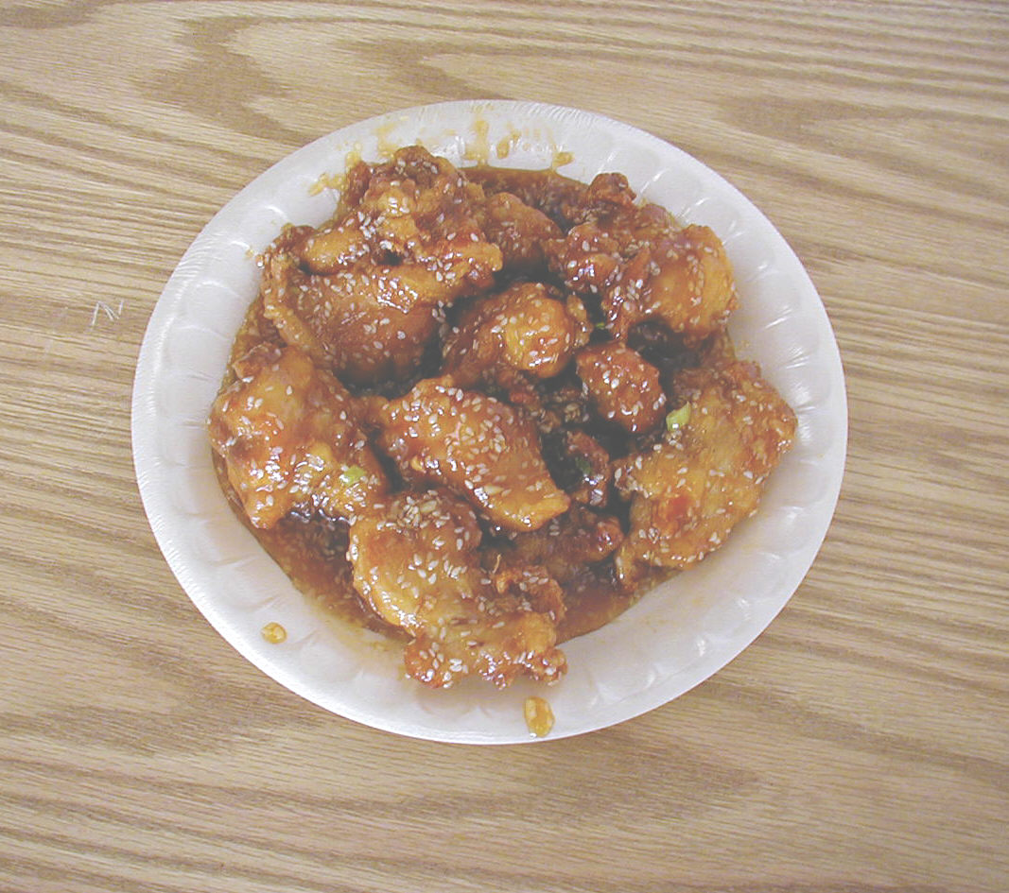
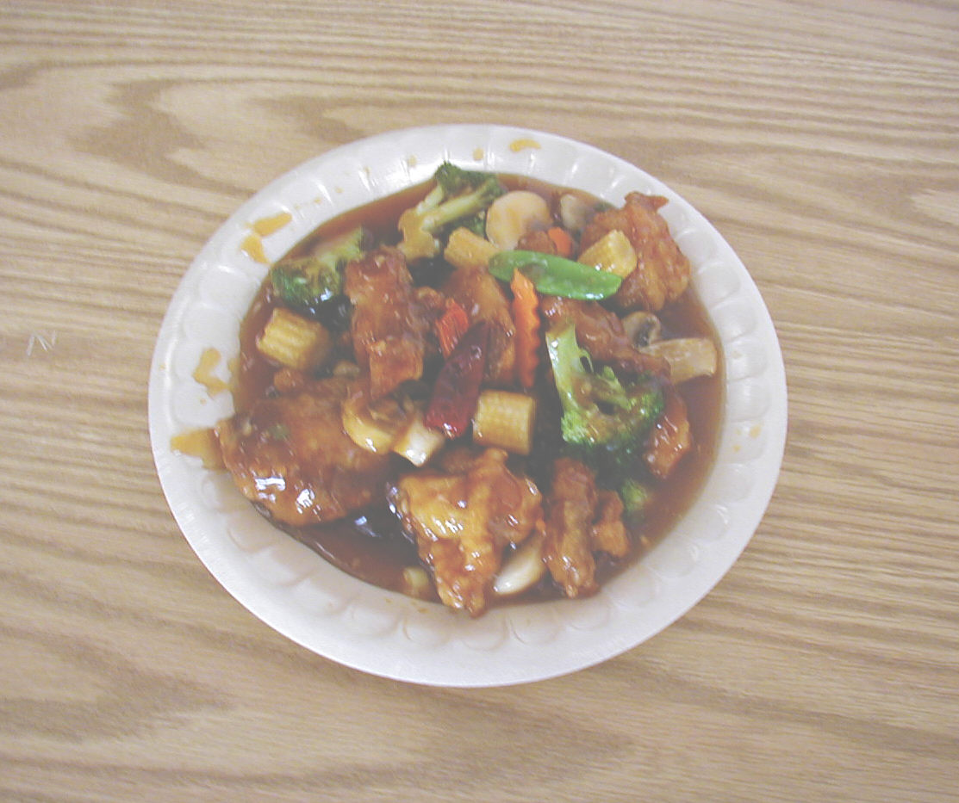
C2. GENERAL TSO’S CHICKEN

C7. FOUR SEASONS
C8. ORANGE CHICKEN
C5. SWEET & SOUR TRIPLE DELIGHT
C1. MANDARIN COMBINATION
C4. SESAME CHICKEN
C3. House bean curd
C6. SCALLION CHICKEN

